Britain is sleepwalking into vulnerability: Without urgent defence investment, we risk learning Ukraine’s lessons the hard way
Jonathan Ray
26 Feb 2026
The UK cannot afford to delay Defence Investment Plan any longer
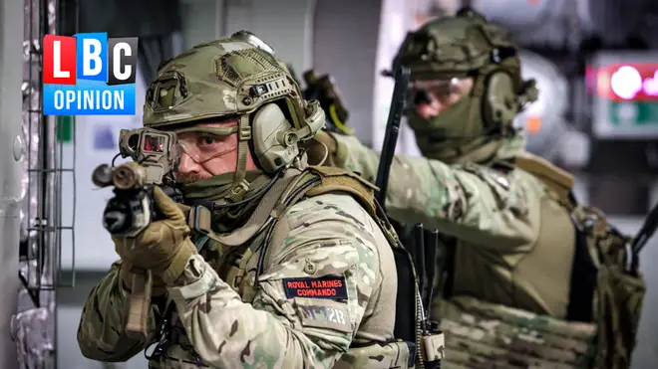Rearm or regret it: Britain cannot afford another year of drift on defence.

The war in Ukraine has now lasted almost the same length of time as World War One.
And the world has felt the profound impact of this war too: lives lost, global supply chain disruption and renewed geopolitical tensions over competition for resources – in this case, critical rare earth minerals. But while being Ukraine’s closest ally, the UK is still moving far too slowly to bolster its own defence and security.
In the Kremlin’s own rhetoric, the UK is increasingly framed as one of Russia’s principal adversaries. Yet, without the long-awaited Defence Investment Plan, there is widespread uncertainty, and the Ministry of Defence has warned that the speed of rearmament risks undermining the UK’s status as a leading member of NATO.
The Russian army possesses the same asymmetric drone capabilities and combat experience as Ukrainian forces. If Western forces were to face a battle-hardened Russian drone unit today, they risk suffering the exact same fate seen in the recent Hedgehog 2025 exercises.
An Estonian systems coordinator bluntly described the result as "horrible" for NATO, noting how easily mechanised units were tracked and eliminated.
As defence spending debates intensify across Europe, there is a risk that increased budgets become an end in themselves. Higher expenditure does not automatically close capability gaps; it’s about spending in the right areas to adapt to modern threats.
Procurement timelines have to be shortened. Decade-long acquisition cycles are no longer fit for purpose, and Britain must prioritise rapid acquisition pathways, working towards 12 to 24-month deployment targets.
Expanding munitions production and enhancing supply chain resilience should also be at the heart of the Defence Investment Plan. UK Defence Equipment & Support must work closely with industry partners such as BAE Systems to accelerate this process.
But the reality is that Ukraine is the only country directly confronting Russia at scale, every day, for four years. From autonomous systems and electronic warfare to distributed drone production and rapid battlefield iteration, Ukraine has compressed decades of defence innovation into months. These capabilities are operational, tested and continuously refined under live combat conditions.
The UK must prioritise deep, structural partnerships and joint ventures with Ukrainian manufacturers.
Collaborating directly with the companies that forge these tools in the crucible of war is the only way for the UK to absorb the battlefield DNA, operational knowledge, and tactical flexibility required to defend against Russian threats.
The UK has a huge opportunity to lead here. Across political cycles, it has remained Ukraine’s most consistent strategic ally. Now is the time to back up the promises to learn from Ukraine with concrete plans and clearly defined frameworks to procure and partner with its innovators.

